 Operation Attention

Please refer to Firing Parameters to get optimal restoration results.

Adjust drying time according to crown or bridge size to ensure ceramics in completely dry condition.
Adjust firing temperature and time according to furnace condition and the quantity of restorations. Make sure vacuum pump is well maintained in order to initiate vacuum condition quickly.

Make sure ceramics are not contaminated by other materials.

Take appropriate amount of ceramics for building up. The remaining exposed ceramics are not suggested to use again.

Safety Warning

Products should be used by trained dental technicians.

Wearing protection suit and mask are suggested during operation.

If in eyes or mouth by chance, rinse immediately with plenty of water.

Powder-allergic personnel are not suggested to use.

Storage

Please seal the bottle porperly after use.

Please store our products in clean and ventilated places, and avoid direct sunlight.

BAOT BIOLOGICAL TECHNOLOGY CO.,LTD.

Add: | No.12 building, Yujing Industry Zone, 106 Qihao Road, Torch Development District,
 | Zhongshan, Guangdong, China. 528400
Tel: | +86-760-87893825 | +86-760-87893826
Fax: | +86-760-87893827 | 0120 ISO13485
Skype: | baotcom | 0120 ISO13485
Website: | www.baot.biz | Version: COP-27-PB-04 A/01
JC
Metal Ceramic

Instructions for Use
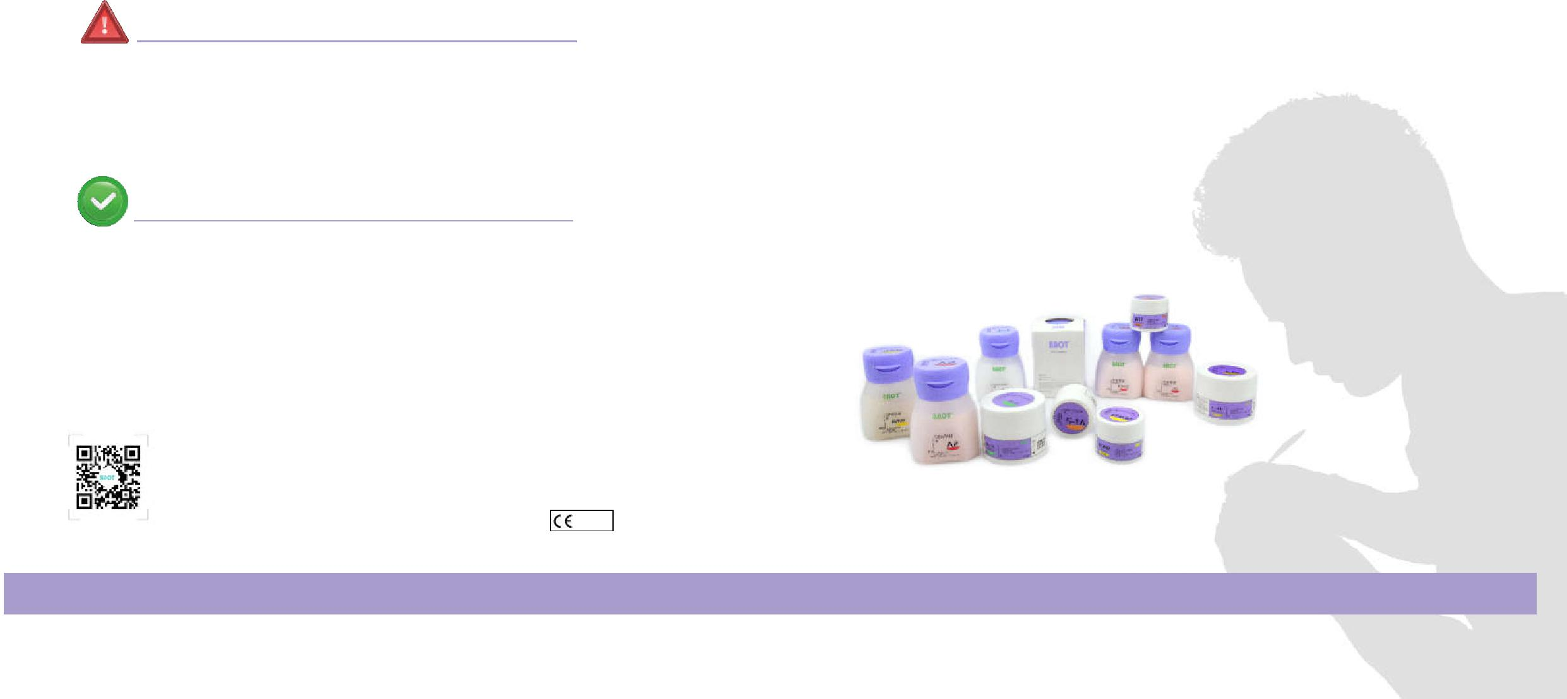

BAOT® BAOT®



Content

Characteristic Features | 02
Basic Technique | 03-09
Advanced Technique | 10-13
Firing Parameters | 14
Shade Matching | 15-16
Troubleshooting Guide | 17-18
BAOT®

Characteristic Features

Life-like shades

1.Colorful shades, classic 16 & 26 shades ceramics

2.Distinct layers & natural colors

Mechanical properties

1.Natural strength

2.Excellent bonding force

Optimal compatibility

1.Compatible with various alloy brands

2.Compatible with other brands’ bonding agents

Tiny particle

1.High density, excellent bonding force, high color intensity 2.Low shrinkage, one step build up

01 Content Characteristic Features 02

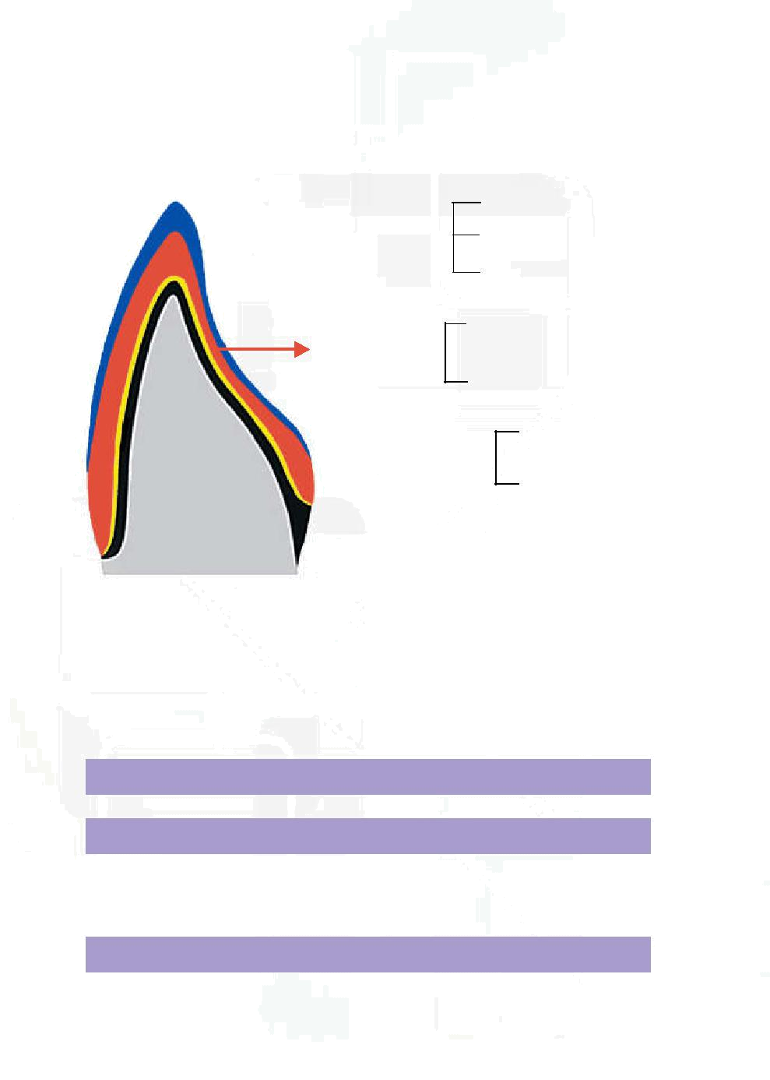

Basic Technique

Ceramic layer distribution

Glaze

 Enamel Layer ^{Transparent}

Incisal

Dentine

Body Layer

Opacious Dentine

Metal frame treatment
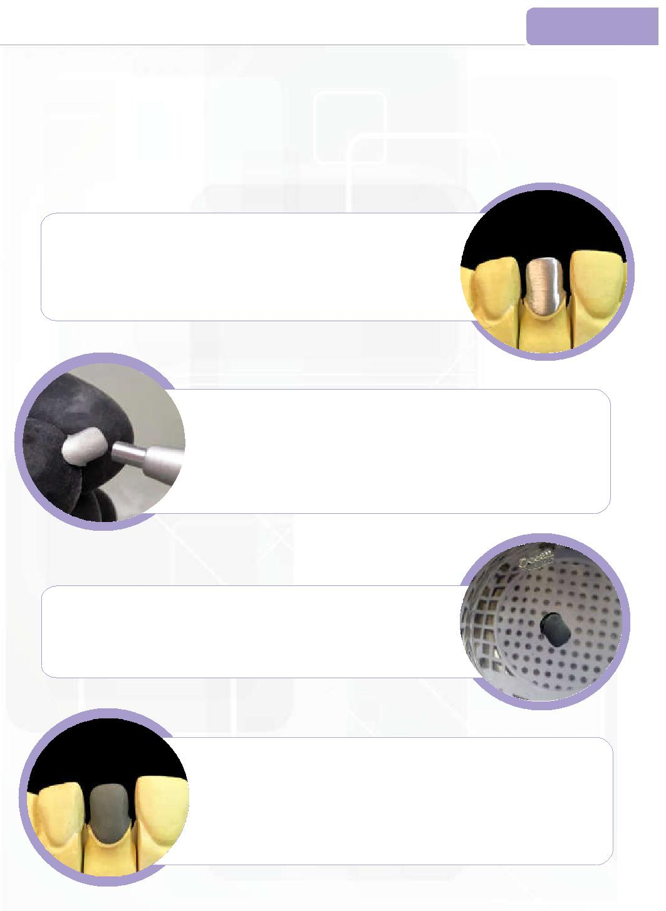
Grinding Metal Frame

Grind the metal frame, to get a smooth surface.

Standard:

1)Metal frame thickness no less than 0.3mm.

2)No sharp edges, to avoid cracks due to thin edges.
BAOT®

BAOT®

BAOT® Sand Blasting

 Opaque Layer

^{Abutment} 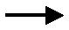 Metal Frame
tooth

*Anterior Teeth Crosscutting Structure

Application procedures

1. | Metal frame treatment

Opaque Paste

Wash Opauqe

Sandblast metal surface, to roughen the frame.

Standard:

Roughen surface, strengthening physical bonding force.

No contamination on metal surface, reducing possibilities of bubble problems.

BAOT®
Ultrasonic Cleaning or Steam Cleaning

Clean metal frame with ultrasonic or steam machine for 1 minute.

Standard:

Clean the frame surface to avoid bubbles.

- Wash Opaque & Opaque application

3. | Dentine application

- Enamel & Transparent application

5. | Contouring & Glaze application

_{BAOT}® Oxidization

Oxidize the metal crown following the metal suppliers’ recommendation.

Standard:

Degas the metal surface, to avoid bubbles. Attention:

Use tweezer to pick up the metal crown after oxidization.

03 Basic Technique Metal frame treatment 04

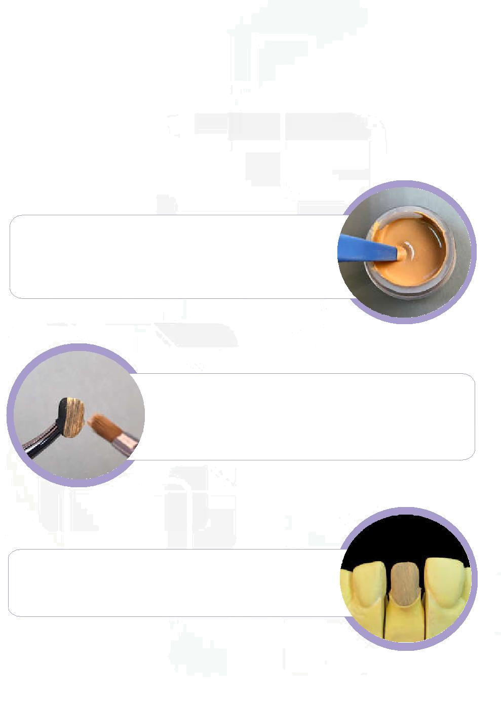

Wash Opaque application

Used for enchancing bonding force and covering metal WO color initially.

Mixing | BAOT®

If Wash Opaque is dry, use Opaque Liquid to get the optimal condition.

* Use plastic stick to mix, avoid mixing with water or other liquid.

BAOT® _{Coating}

Use flat-end brush to coat a thin layer of Wash Opaque on metal crown before firing.

- Avoid water in the brush.

- Seal the Wash Opaque bottle after use to avoid contamination.

BAOT®
Firing

* Fire Wash Opaque referring to the Firing Parameters.
BAOT®
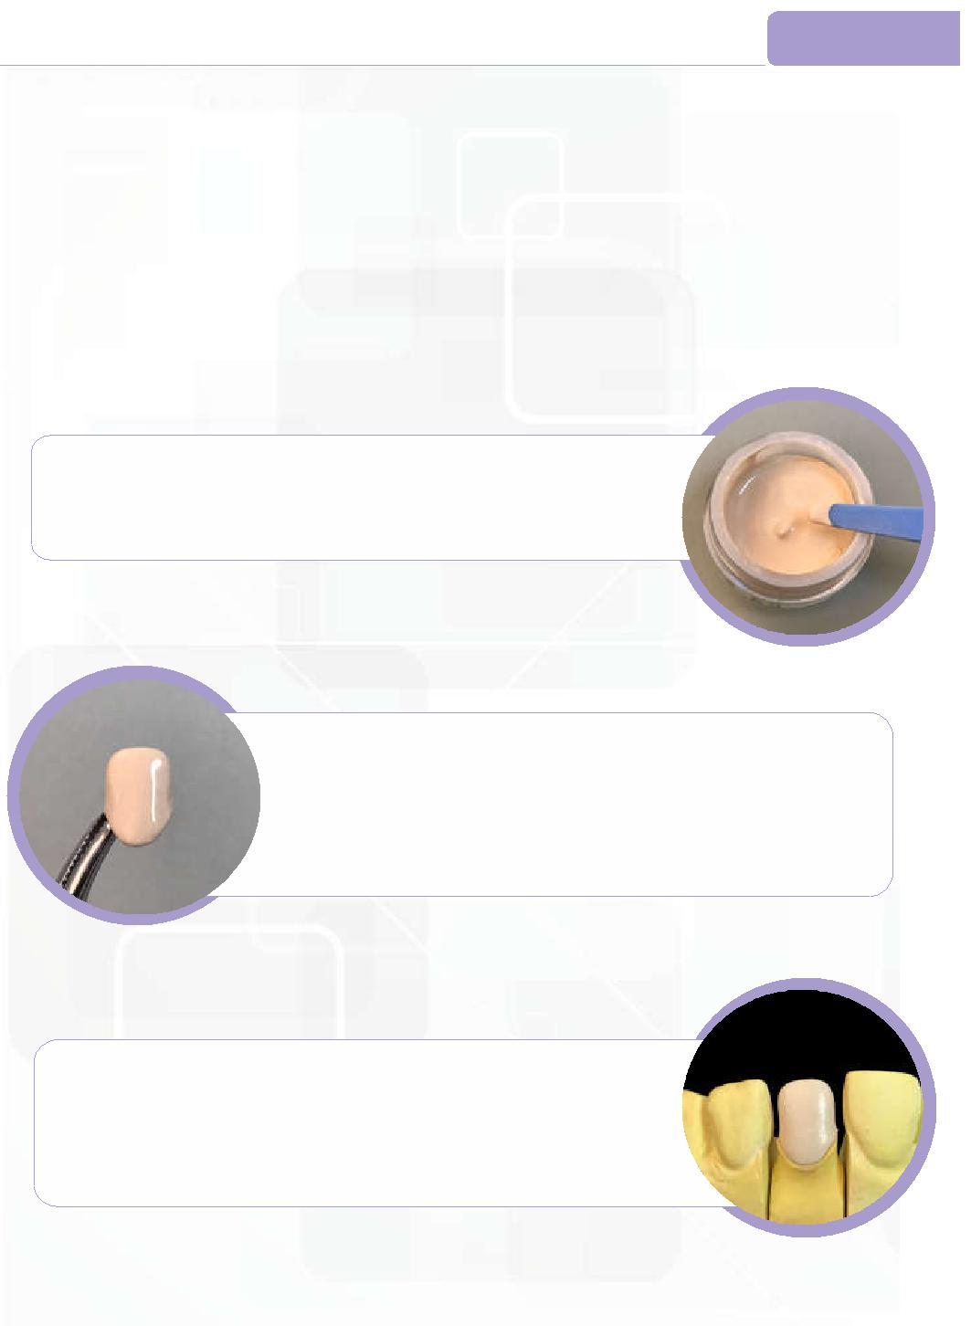

Opaque application

OP Used for covering metal color and differentiating shades.

Mixing BAOT®

If Opaque is dry, use Opaque Liquid to dilute it and get the optimal condition as shown in the picture.

* Use plastic stick to mix, avoid water or other liquid.

BAOT® Coating

Use plastic stick to coat Opaque evenly on the surface, covering metal color.

Fire until Opaque layer is baked dry.

* Vibrate metal crown after Opaque coating, to ensure Opaque is well laid on the crown.

Firing | BAOT®

Fire referring to Firing Parameters.

- Preheat metal crown until Opaque layer looks white before firing, to avoid bubbles and cracks.
- Opaque layer should be smooth and metal color should not be seen, otherwise additional Opaque layer shall be applied.

05 Wash Opaque application Opaque application 06

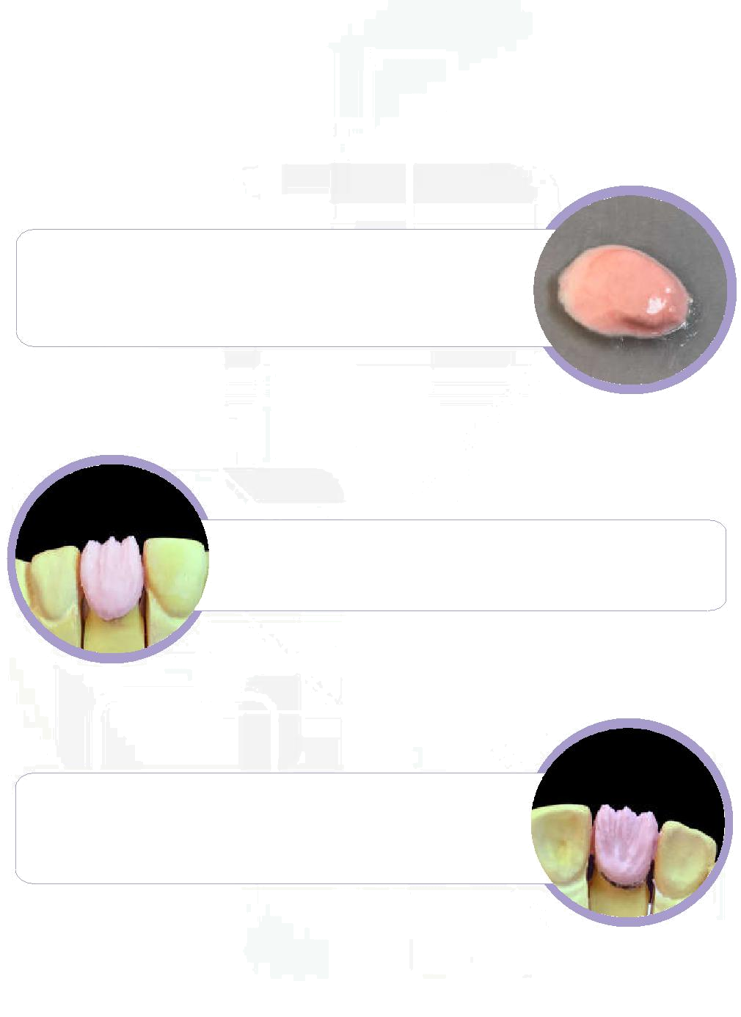

Dentine application

Mixing BAOT®

Use Modeling Liquid to mix Dentine powder until it becomes pasty, as shown in the picture.

* Don’t make it too dry or too wet.

BAOT®
Building up Dentine

Judge the size of Dentine layer based on space and occlusion.

Due to shrinkage effect, normally Dentine layer should be around10% larger to compensate the firing shrinkage effect.

BAOT®
Attention
BAOT®
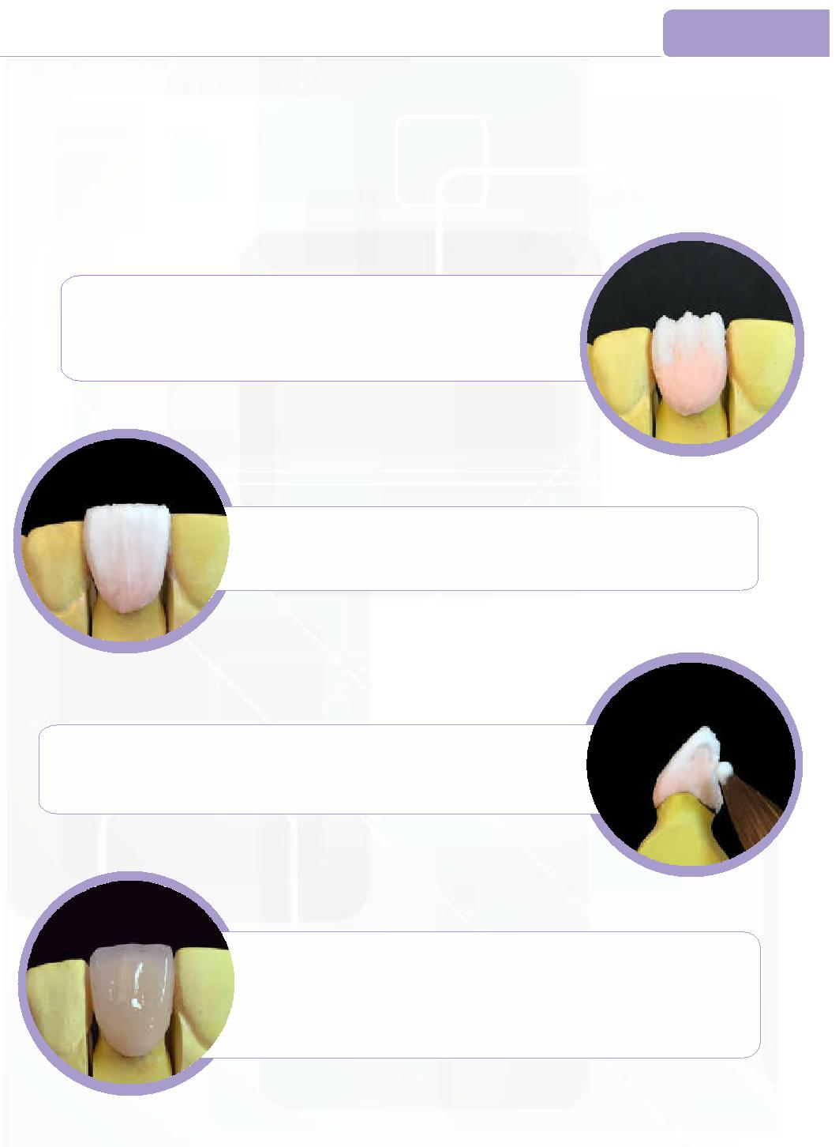

Enamel & Transparent application

Building up Enamel BAOT®

Apply Enamel ceramic to the incisal 1/3.

* Use brush to compact and smoothen surface.

BAOT®

Building up Transparent

Apply Transparent to the incisal 2/3 if needed, covering Enamel.

Slight overbuilding is allowed at incisal area.

BAOT®

Add-on

Add-on Dentine & Transparent to interproximal space if needed

*Use tweezer to pick up crown.

Cervical shade of natural tooth is darker than Dentine layer. The thickness of Dentine layer should be thinner from the

BAOT®

Firing

cervical 1/3 to the incisal 1/3 in order to reserve space for Enamel and Transparent layer.

Fire referring to the Firing Parameters.(See P14)

*Insufficient firing or over firing may lead to unstable crystalline structure and undesired shades.

07 Dentine application Enamel & Transparent application 08

