BAOT®
BAOT BIOLOGICAL TECHNOLOGY CO.,LTD.

Add: | No.12 building, Yujing Industry Zone, 106 Qihao Road, Torch Development District,
 | Zhongshan, Guangdong, China. 528400
Tel: | +86-760-87893825 | +86-760-87893826
Fax: | +86-760-87893827
Skype: | baotcom |  | 0120 | ISO13485
Website: | www.baot.biz |  | Version: COP-27-PB-06 A/01

ZCG
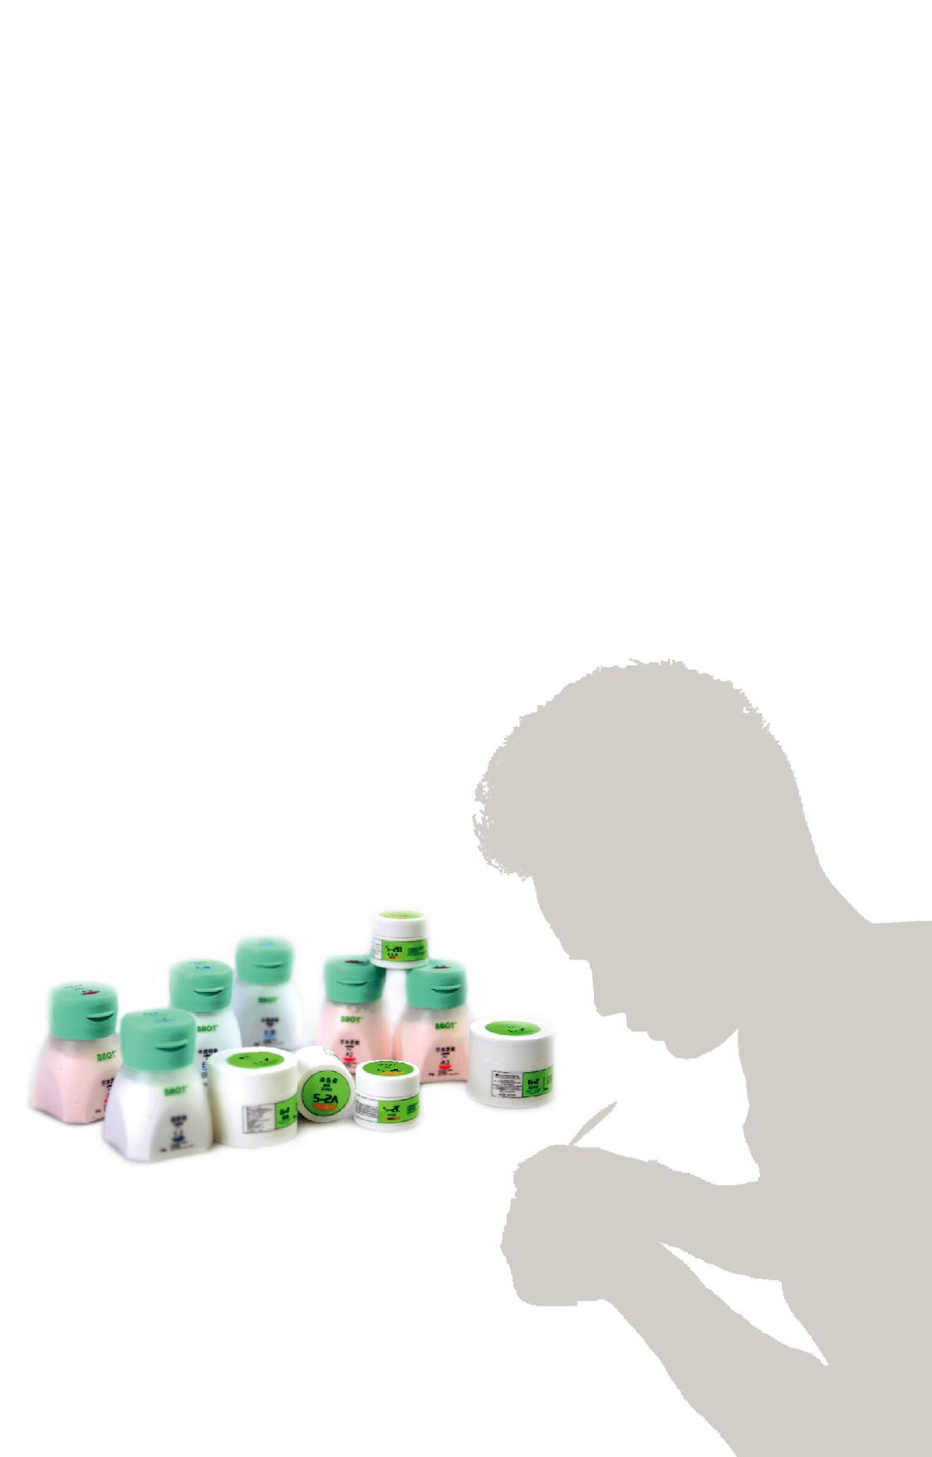
Z i r c o n i a C e r a m i c

Instructions for Use

BAOT®

BAOT®

Content |  | Characteristic Features
 |  | Life-like shades
Characteristic Features | 02
 |  | 1 | . Colorful shades, classic 16 & 26 shades ceramics
Application Procedures | 03-07 | 2. Distinct layers & natural colors
Firing Parameters | 08 | Mechanical properties
Shade Matching | 09-10 | 1 | . Natural strength
Shade Matching | 09-10 | 2 | . Excellent bonding force
Troubleshooting Guide | 11-12
Attention | 13-14 | Optimal compatibility
 |  | 1 | . Compatible with various Zirconia coping brands
 |  | 2 | . Compatible with other brands’ bonding agents
 |  | Tiny particle
 |  | _{1.} High density, excellent bonding force, high color intensity
 |  | 2 | . Low shrinkage, one step build up

01 Content Characteristic Features 02

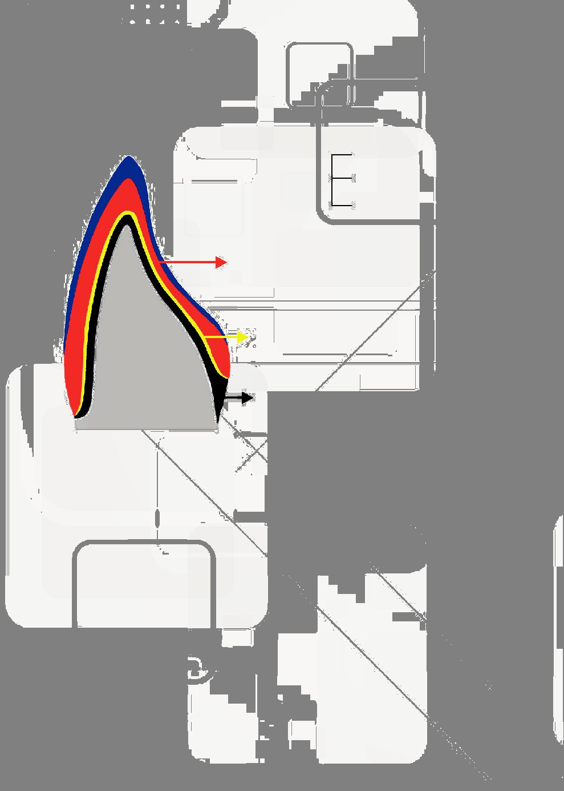

Application Procedures

Ceramic layer distribution

Glaze

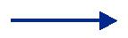 Enamel Layer ^{Transparent}

Incisal/Enamel

 | Body Layer |  |  | Dentine
 | Bonding Layer |  |  |  | Dentine
Abutment | Zirconia Coping
tooth

*Anterior Teeth Crosscutting Structure

(ceramic layer distribution)

Application procedures

1. | Coping treatment
2.
2. | Bonding layer
3. | Dentine application
4. | Enamel & Transparent application
5. | Contouring & Glaze application
BAOT®
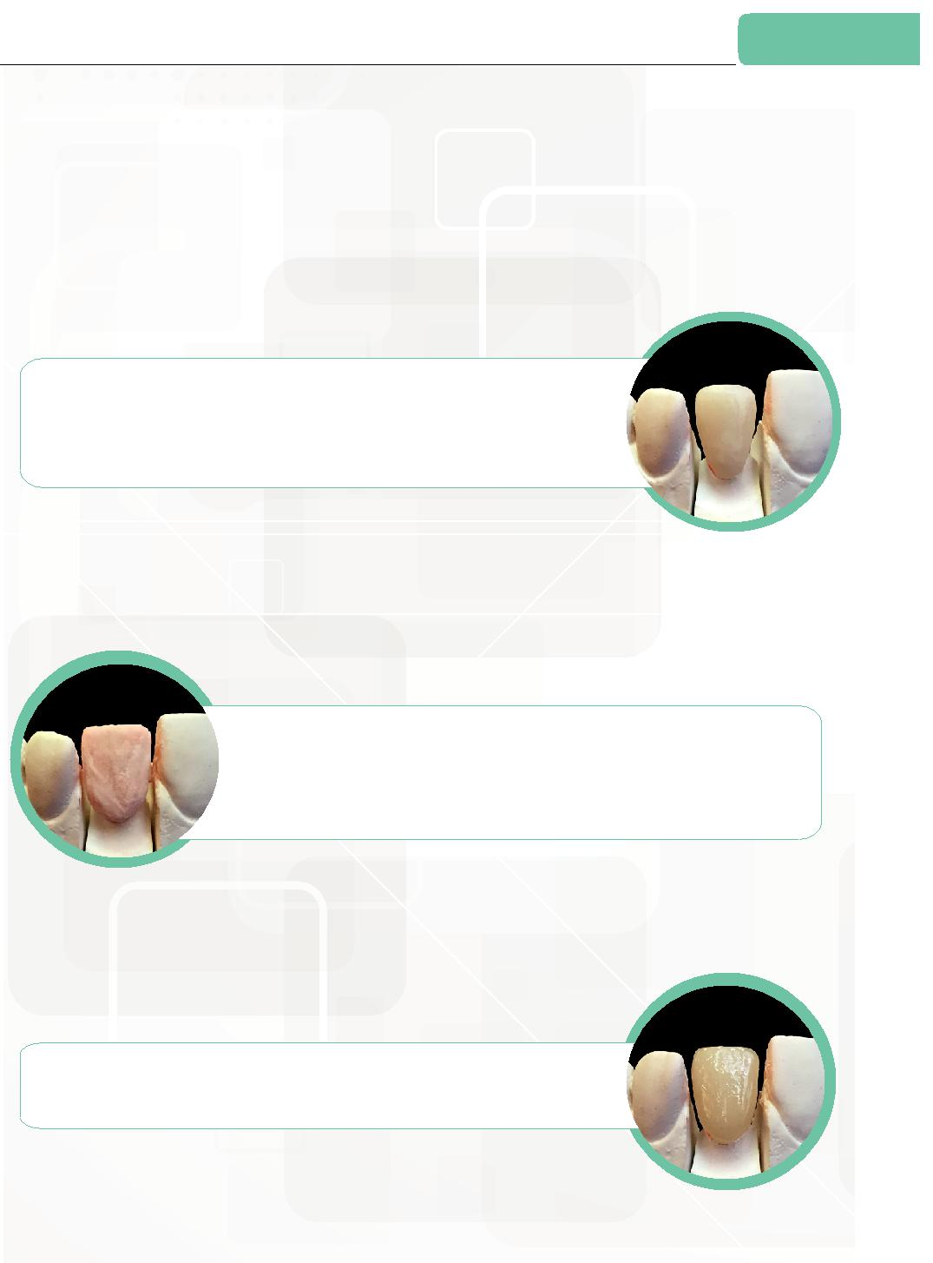

Coping treatment & Bonding layer

Checking BAOT®

Check whether coping design is acceptable in terms of

size, length and thickness by putting coping onto plaster model. If unacceptable, grind or redesign it.

^{BAOT®} Bonding layer build up

Apply a thin layer of Dentine on coping surface as the bonding layer

before heat treatment. Roughen the coping surface to strengthen the

bonding force between coping and dentine.

BAOT®
Heat treatment

Heat treatment referring to Firing Parameters.

03 Application procedures Coping treatment & Bonding layer 04

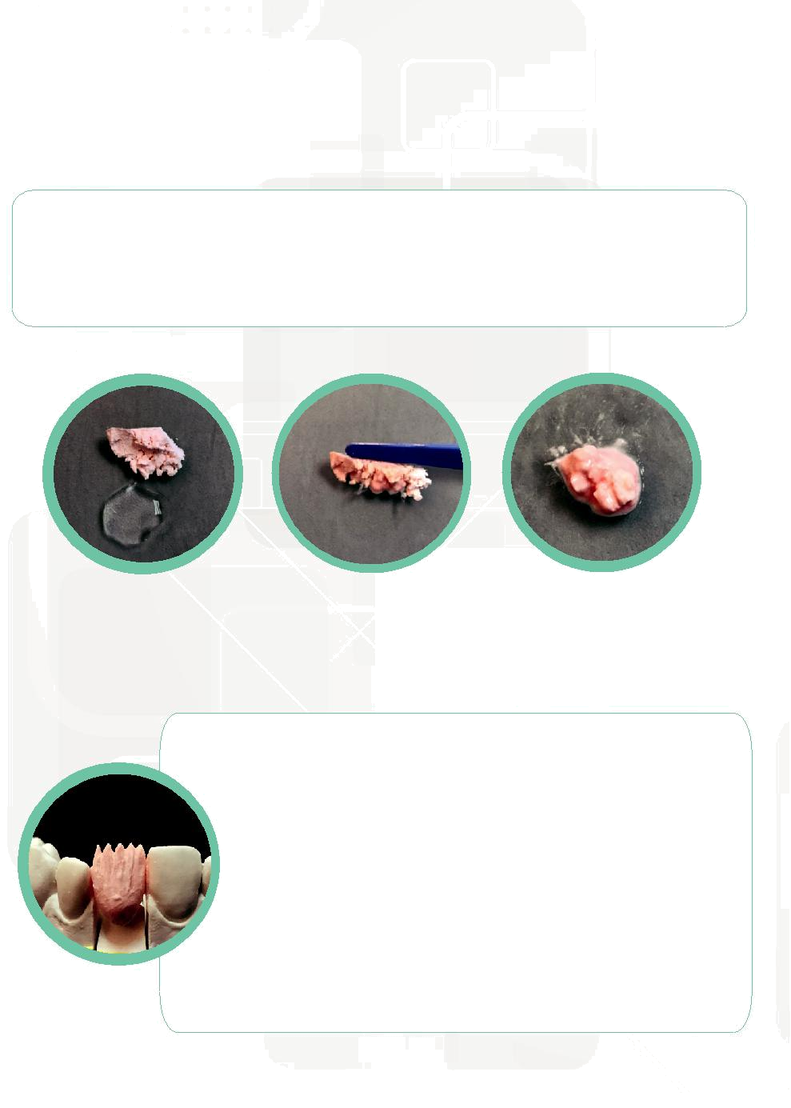

Dentine application

Mixing

Use Modeling Liquid or distilled water to mix Dentine powder until it becomes pasty, as shown in the picture 1& 2.

Mix the Dentine into paste evenly and completely, as shown in the Picture 3. Don’t make it too dry or too wet.

BAOT® BAOT® BAOT®

Picture 1 Picture 2 Picture 3

Dentine build up

Judge the size and length of Dentine layer based on adjacent space and occlusion.

_{BAOT}® Due to shrinkage effect after firing, normally Dentine layer shall be 10% larger to compensate the firing shrinkage.

Absorb water during Dentine application, in order to make Dentine paste solid on the coping and to avoid chipping or moving which may lead to cracks, bubbles and mixed shades.

Dentine in interproximal area must be solid and linked, to avoid cracks by firing shrinkage.

Make sure Dentine covers all edges to avoid exposed area caused by firing shrinkage.
BAOT®
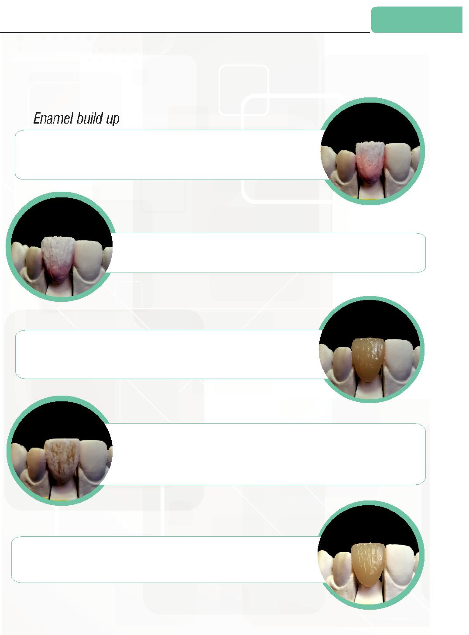

Enamel & Transparent application

BAOT®

Apply Enamel to the incisal 1/3.

Use slightly wet brush pen to pull Enamel, making ceramic layers bonded tightly.

BAOT®

Transparent build up

Apply Transparent to the incisal 2/3, covering Enamel.

BAOT®
Firing

Firing according to the Firing Parameters.

If the ceramic is too wet before firing, lengthen the firing time.

BAOT® _{Add-on}

Use brush to vibrate tweezer slightly and absorb water to make ceramic condensed.

Repeat until no water seep out.
Do not condense too heavily. Avoid ceramic layers collapsing or mixing.

BAOT®
Firing

Add-on firing temperature should lower than the first firing.

Refer to Firing Parameters.

05 Dentine application Enamel & Transparent application 06

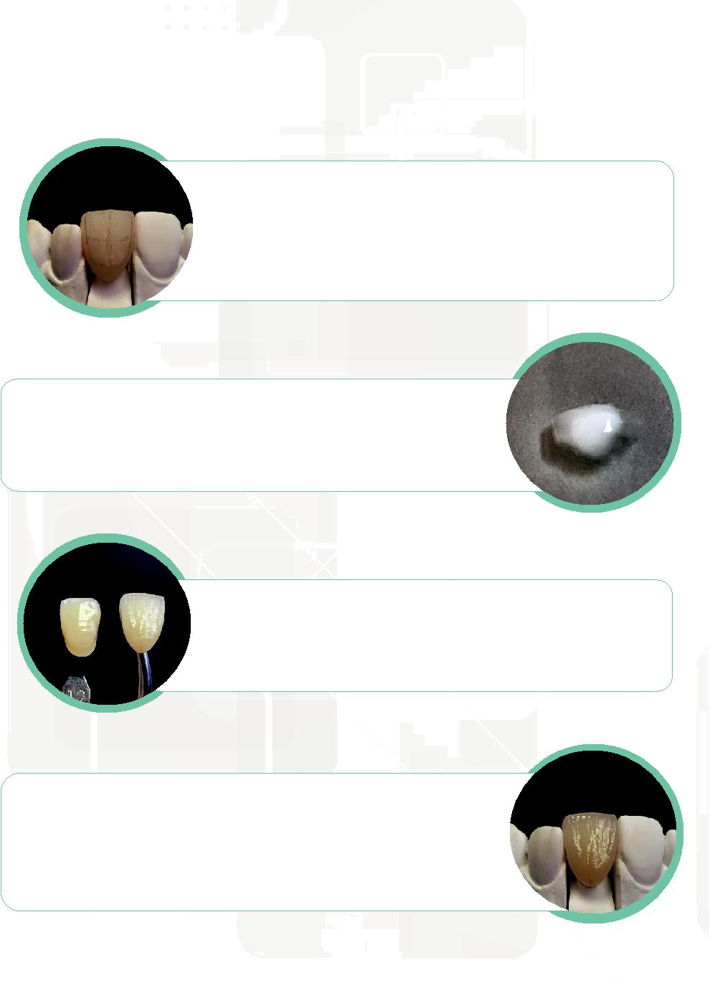

Countouring & Glaze application

Contouring
BAOT®

After firing, use non-contaminated stones, discs, or diamond burs to refine the anatomy. Check whether additional ceramics are needed.

If additional are required, firing temperature should be 5℃-10℃ lower than the first firing.

* Add-on too many times is not recommended, or it may lead to undesired results.

Glaze Mixing | BAOT®

Mix Glaze powder with Glaze & Stain Liquid, making it pasty &thoroughly. If the glaze paste is too dry or too watery, it may lead to insufficient glossiness.

^{BAOT®} Coating & Shades matching

Coating should be evenly distributed. Don’t coat it heavily.
Match shades with a SHADE GUIDE.

If required, use the tip of the staining brush to spread a thin film of Stain
Liquid until satisfactory shade is obtained.

Firing _{BAOT}®

After Glaze application, fire the coping under atmosphere pressure according to the Firing Parameters.

- If ring temperature is higher than the Firing Parameters, it may lead to circular formation and unnatural over-glossy surface and opacity.

- If ring temperature is lower than the recommended parameter, it may lead to matt and rough surface.
BAOT®

Firing Parameters

Condition | Coping | Body | Add-on | Glaze & Stain
Condition | Heat treatment | Body | Add-on | Glaze & Stain
Drying temp.(℃) | 550 | 500 | 500 | 500
Drying time(min) | 2 | 3 | 2 | 2
Heating time(min) | 2 | 3 | 2 | 2
Heating rate(℃/min) | 50 | 50 | 50 | 50
Firing temp.(℃) | 930 | 920 | 910 | 900
Holding time(min) | 1 | 1 | 1 | 1
Cooling time(min) | 4 | 4 | 4 | 4
Cooling temp.(℃) | 550 | 550 | 550 | 550
Vacuum start(℃) | 500 | 500 | 500 | -
Vaccum end(℃) | 930 | 920 | 910 | -

Note:

This Firing Parameters chart is only for reference. Optimal results will be obtained during practical operation.

Firing temperature and holding time shall be adjusted according to furnace condition, crown design and bridge length.

07 Contouring & Glaze application Firing Parameters 08

